**Report: LR Delivery time prediction**

Include your visualizations, analysis, results, insights, and outcomes. Explain your methodology and approach to the tasks. Add your conclusions to the sections.

## **Data Preprocessing and Feature Engineering**

* 1. **Fixing the Datatypes**

Converted created_at and actual_delivery_time to datetime type

dataframe['created_date_time'] = pd.to_datetime(dataframe.created_at)

dataframe['actual_delivery_date_time'] = pd.to_datetime(dataframe.actual_delivery_time)

* 1. **Calculated duration for order completion**

result = []

for (actual, created) in zip(dataframe.actual_delivery_date_time, dataframe.created_date_time):

duration = actual - created

result.append(duration)

dataframe['time_for_delivery'] = result

* 1. **Created two more columns day_of_the_week and month**

dataframe['day_of_the_week'] = dataframe['created_date_time'].apply(lambda x: x.weekday() + 1)

dataframe['month'] = dataframe['created_date_time'].dt.month

dataframe['month'] = dataframe['month'].apply(lambda x: x)

* 1. **Introducing new column isWeekend**

# Create a categorical feature 'isWeekend'

**def isweekend(day):**

**if day == 6 or day == 7:**

**return 1**

**else:**

**return 0**

**dataframe['isWeekend'] = dataframe['created_date_time'].apply(lambda x: isweekend(x.weekday() + 1))**

|  |
| --- |
| **# Drop unnecessary columns**  **dataframe = dataframe.drop('actual_delivery_time', axis =1 )**  **dataframe = dataframe.drop('store_primary_category', axis =1 )**  **dataframe = dataframe.drop('time_for_delivery', axis =1 )**  **dataframe = dataframe.drop('created_at', axis =1 )** |

* 1. **Added new column for date of order**

**dataframe['date'] = dataframe['created_date_time'].dt.day**

## **Exploratory Data Analysis**

**Note: I am splitting data into train and test data after EDA.**

### **Distribution of time_taken**

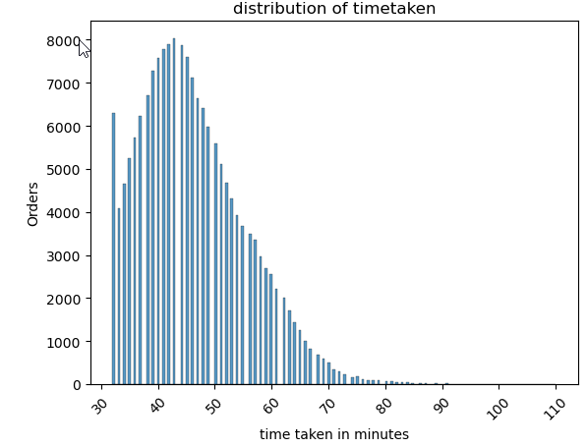

### **Finding correlation of columns**

dataframe.corr(numeric_only=True)

gave the correlation details of all columns, which helped drop least correlated columns

plt.figure(figsize = (16, 10))

sns.heatmap(dataframe.corr(numeric_only=True), annot = True, cmap="YlGnBu")

plt.show()

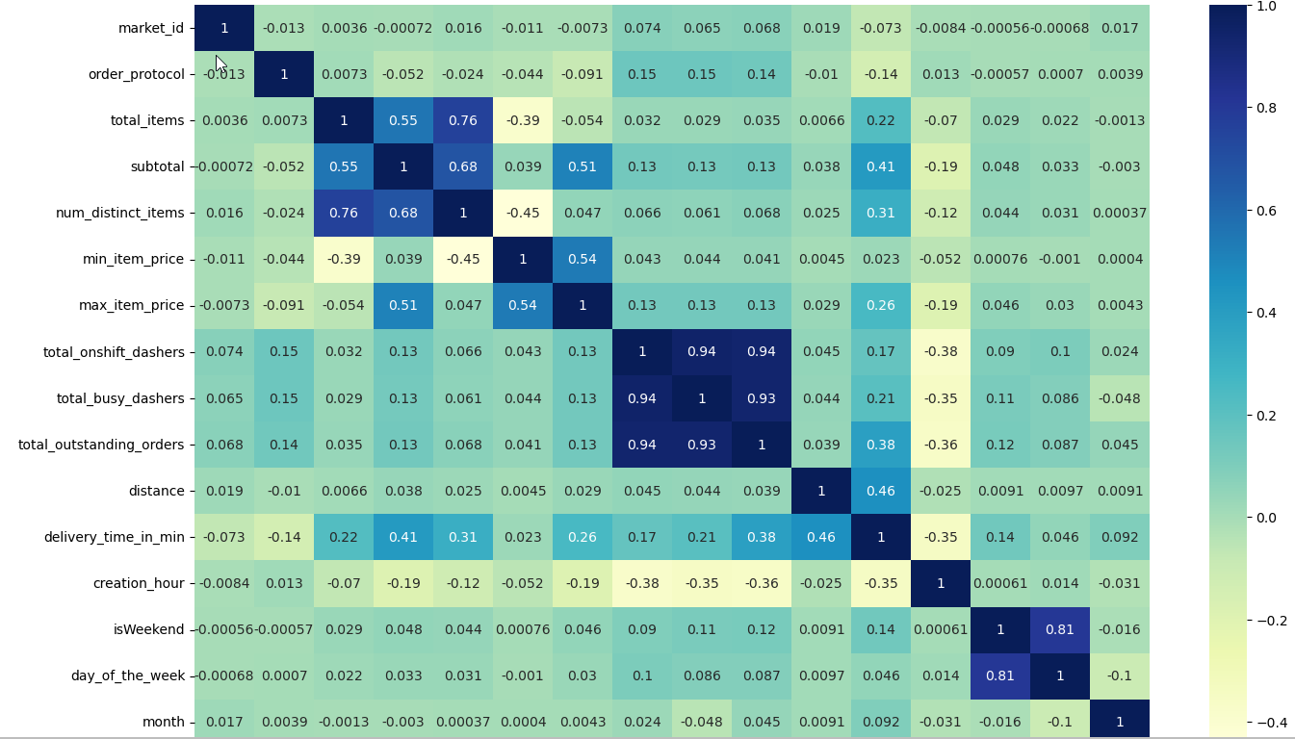

|  |
| --- |
| **# Drop 3-5 weakly correlated columns from training dataset**  # identified columns to drop market_id, order_protocol, min_item_price, creation_hour,total_onshift_dashers  tobedel = ['market_id', 'order_protocol', 'min_item_price', 'creation_hour']  dataframe = dataframe.drop(tobedel, axis=1) |

### **2.3 Handle outliers present in all columns**

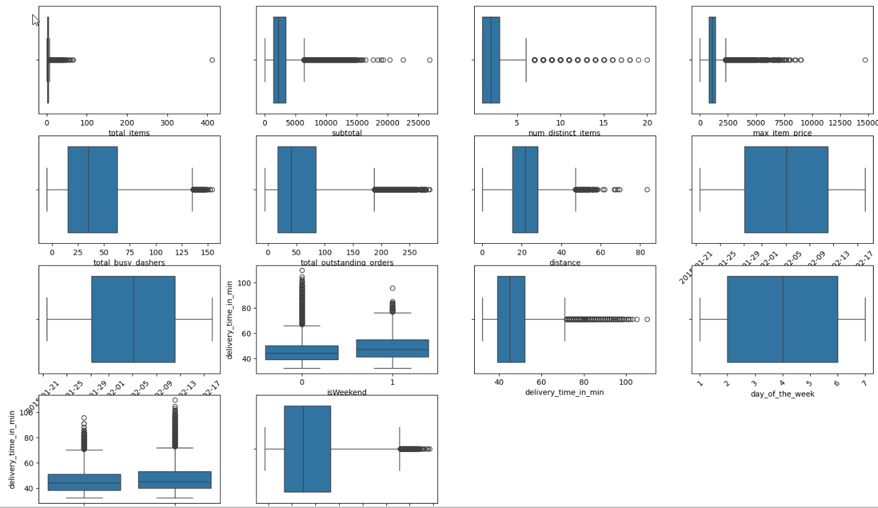

## **Creating training and validation sets**

|  |
| --- |
| df_train, df_test = train_test_split(dataframe, train_size = 0.7, test_size = 0.3, random_state = 100)  y = df_train.pop('delivery_time_in_min')  X = df_train |

## 4. Model Building

### **4.1 Feature Scaling**



### **4.2 Build a linear regression model**



|  |
| --- |
| Hence dropped columns total_onshift_dashers and total_busy_dashers |

### **4.3 Train the model using the training data and Make predictions**



### **Build the model and fit RFE to select the most important features**



## **Results and Inference**







|  |
| --- |
| **Inference:**  The model perform moderately good with following columns :  ['subtotal','num_distinct_items','max_item_price','distance','isWeekend','day_of_the_week','month','total_outstanding_orders','creation_hour','date']  With r-squared 52% and VIF of all columns |

## 6. Subjective Questions

### 6.1 Are there any categorical variables in the data? From your analysis of the categorical variables from the dataset, what could you infer about their effect on the dependent variable?

|  |
| --- |
| Ans: These are categorical columns in the data market_id, created_at, actual_delivery_time, order_protocol  I extracted hours, months, day of the order, to make better predictions from datetime columns. Market_id had order_protocol had week correlation with other columns hence dropped them. Month, day of the week had little better correlation and helped get better regression model. |

### 6.2 What does test_size = 0.2 refer to during splitting the data into training and test sets?

|  |
| --- |
| Ans: which means split data into 2-part train data and test data, where test data size 20% of total data. |

### 6.3 Looking at the heatmap, which one has the highest correlation with the target variable?

|  |
| --- |
| Ans:  distance 0.460173 |

### 6.4 What was your approach to detect the outliers? How did you address them?

|  |
| --- |
| Ans:  I drew box plots for each column to identify potentials outliers, and cleaned columns one by one, starting from column with highest outliers to lowest. |

### 6.5 Based on the final model, which are the top 3 features significantly affecting the delivery time?

|  |
| --- |
| Ans:  Distance, isWeekend and num_distinct_items |

### 6.6 Explain the linear regression algorithm in detail

|  |
| --- |
| Ans:   1. I started modeling with all 12 columns(['total_items', 'subtotal', 'num_distinct_items','max_item_price','total_onshift_dashers','total_busy_dashers','total_outstanding_orders','distance','isWeekend','day_of_the_week','month','creation_hour','date']) 2. Computed VIF for the model, which indicated potential multicollinearity for the columns (total_onshift_dashers : 12.64, total_busy_dashers: 12.33, total_outstanding_orders: 10.30) 3. In the second model dropped total_onshift_dashers. 4. Computed VIF(total_outstanding_orders : 8.34, total_busy_dashers: 8.26) 5. In the third and final model dropped (total_outstanding_orders) 6. R-squared = 0.523 7. VIF for all columns is less than 5, which strongly eliminates multicollinearity. 8. Residual histogram also is normally distributed around 0. |

### 6.7 Explain the difference between simple linear regression and multiple linear regression

|  |
| --- |
| Ans:  Simple linear regression involves only one feature that helps in prediction.  Multiple linear regression invloves 2 or more features for prediction, this comes with risk of having multicollinearity, which might wrongly impact model by overfitting. |

### 6.8 What is the role of the cost function in linear regression, and how is it minimized?

|  |
| --- |
| Ans:  Measures the performance of a machine learning model for a given dataset.  Minimize this error by adjusting its parameters either by adding new parameters or removing tightly correlated columns. |

### 6.9 Explain the difference between overfitting and underfitting.

|  |
| --- |
| Overfitting: The model is too complex and fits the training data too closely, which is like memorizing all datapoints. |
| Underfitting: The model is too simple leading to low model accuracy. |

### 6.10 How do residual plots help in diagnosing a linear regression model?

|  |
| --- |
| Residual plot represents the "leftover" variation in the data that the model hasn't explained. Which visually reveals patterns or trends in the residuals. Helps in identifying Homoscedasticity **,** Outliers |